http://www.luquescurtis.com
Luques Curtis
BIO
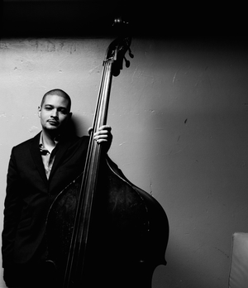
Luques Curtis was born in 1983, in Hartford, Connecticut. After having formal training on piano and percussion, he found himself wanting to play the bass. Luques studies at the Greater Hartford Academy of Performing Arts, Artist Collective, and Guakia with Dave Santoro, Volcan Orham, Nat Reeves, Paul Brown, and others. While attending high school, he was also very fortunate to study the Afro-Caribbean genre with bas greats Andy Gonzalez, and Joe Santiago. With his talent and hard work, he earned a full scholarship to the prestigious Berklee College of Music in Boston. There, he studied with John Lockwood and Ron Mahdi. While in Boston, he was also able to work with great musicians such as Gary Burton, Ralph Peterson, Donald Harrison, Christian Scott, and Francisco Mela.
Now living in the New York area, Mr. Curtis has been performing worldwide with Eddie Palmieri, Brian Lynch, Ralph Peterson, Christian Scott, Sean Jones, Orrin Evans, Albert Rivera, and others. He is the recent recipient of the 2016 Downbeat Rising Star Bassist on the Critics’ Poll. He also co-owns a record label called Truth Revolution Records. Alongside his brother, they have four releases under “Curtis Brothers,” the most recent being “Syzygy.” Luques was also part of Brian Lynch’s GRAMMY-winning CD, “Sympatico,” and his GRAMMY-nominated “Madera Latino” as well as Christian Scott’s GRAMMY-nominated CD “Rewind That.” He also produced the GRAMMY-nominated “Entre Colegas” by Andy Gonzalez. You can hear him on Eddie Palmieri’s “Sabiduria,” Gary Burton’s “Next Generations,” Dave Valenin’s “Come Fly with Me,” Sean Jones’ “Roots,” “Kaleidoscope,” and “The Search Within,” Albert Rivera’s CD “Re-Introduction,” Etienne Charles’ CD “Folklore,” and Orrin Evans’ CD “Faith in Action.”
As a sideman, Luques Curtis has participated in over 75 recordings.

