***Blujazz*** Recording Artist [Walter Kemp 3](https://www.walterkemp3.com/), lead composer and pianist for the [*Walter Kemp 3oh!*](https://www.walterkemp3oh.com/), has won widespread critical acclaim for his classic and compelling musical compositions. His work has won numerous awards, including awards for “Best Jazz Group.” The *3oh!* features RiShon Odel (bassist for GRAMMY-Nominated Najee) and master percussionist David Hulett. The brand-new vinyl/digital release ***“DarkRoom”*** shows the inventive trio in full force both in composition and collaborative energy. The Walter Kemp 3oh!’s debut release ***“Dark Continent”*** (BJ3440) is sparking interest both nationally and internationally, already having been featured on Toronto Jazz 91.1FM. George W. Harris, of *LA Jazz Weekly* noted that the album “swings with excitement…Kemp is richly expansive …the whole team is…anything but the expected piano trio.”

The son of a Carnegie Hall classical and gospel composer, Kemp is classically-trained in piano. Also a drummer, he gravitated to jazz, and studied improvisation with B3 ace Bobby Jones, and GRAMMY-award winning pianist George Caldwell. Winning widespread critical acclaim for his own unique and compelling compositions that bravely delve within the realm of the unexpected, he is the winner of Night Life Magazine's 2012, 2013, and 2014 Music Award for "Best Original Keyboard Player,” and boasts collaborative and recording partners **Joseph Wooten** (Steve Miller Band), **Sabu Adeyola** of Ahmad Jamal Trio (and protégé to the late Charles Mingus), the legendary **Juini Booth**, **Rey Scott** of Sun-Ra's Arkestra, **Scott Tixier** and **Bobby Militello** of the Dave Brubeck Quartet.

With his international touring and recording repertoire, Kemp has shared stages with **Dave Stryker**, **The Hot Sardines**, **Otis Brown, III**, **Joel Frahm**, **Luques Curtis**, and others, and has collaborated with various musical greats as a highly-sought professional in the progressive music scene. Kemp serves as Artistic Director for the *CMC Jazz Fest*, celebrating over 100 years of jazz presentation.

For his own ensembles, he composed major works for his European tour (spanning five countries). Kemp’s participation in touring groups and orchestras across Africa, Europe and North America has allowed him to push the musical envelope, drawing the area's most creative musical artists together for long-term collaborative work. Grüvology’s latest recording entitled, "Freeway,” features all original work. For four consecutive years, Grüvology has been awarded top honors, including the 2015 "Best Western New York Jazz Group.” In the 2015 Jazz Buffalo Reader’s Poll, the ensemble won "Best Jazz Group" and “Best Jazz-Infused Group.” The band was also ArtVoice's staff pick for "Best Jazz Group" in the WNY Music Awards.

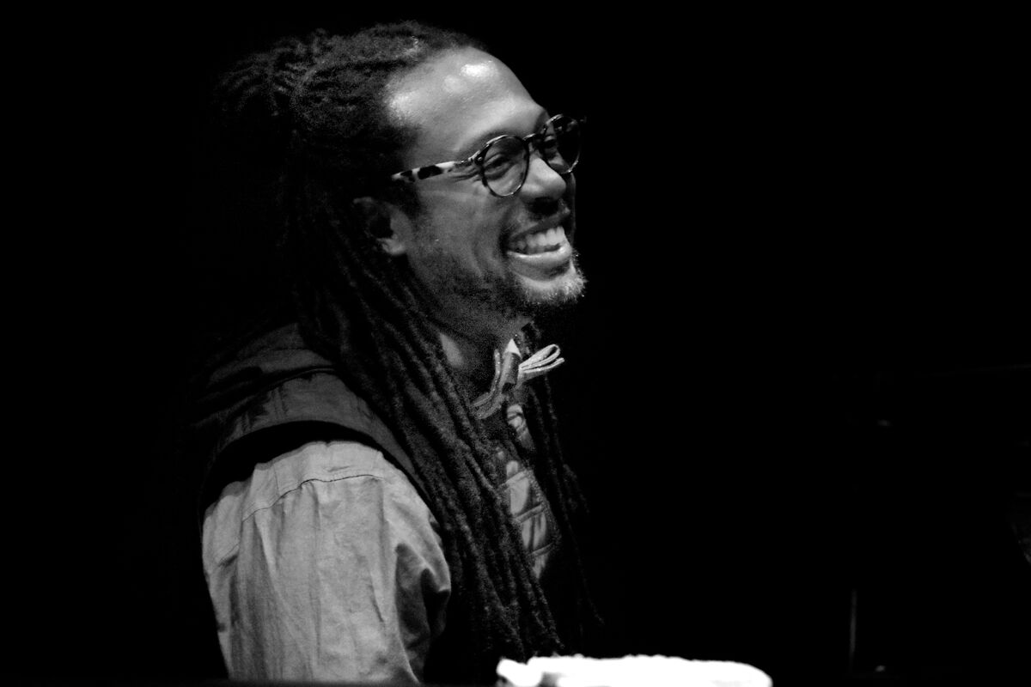

**Walter KEMP 3** BIO